Explainable Multimodal AI for Early Detection of Learning Engagement and Emotional States in Children Using Eye Movement
Ilakkiya S (Orcid), Adhvaith N A (Orcid), Don George (Orcid)
School of Computer Science and Engineering, Vellore Institute of Technology, Vellore (India)

Abstract
Recognition of learner engagement from webcam video is limited not only by the classification task but by the variable quality of the observations. Quality-aware pipelines usually discard frames below a threshold, which breaks the regular temporal sampling that sequence models depend on. This paper evaluates an alternative in which reliability is a soft, length-preserving weight: a five-component Motion Reliability Score, computed from observation-quality evidence alone and combined by learned weights, scales the per-frame embeddings of a Vision Transformer and the temporal pooling of a Mamba encoder without removing any frame. On the full DAiSEE release, using the official subject-disjoint partition, the system detects disengagement at a ROC-AUC of 0.794 against a 0.5 no-signal baseline, recovering 54 of 88 disengaged test clips. A controlled ablation differing in two of 117 settings measures the reliability mechanism's own contribution at 0.0002 ROC-AUC, and SHAP attribution localises the discriminative signal to eye-openness and gaze geometry.
Keywords
Affective Computing, Engagement Recognition, Explainable Artificial Intelligence, State-Space Models, Vision Transformer.

Introduction
E
NGAGEMENT is among the strongest predictors of learning outcome, and measuring it has become more pressing as instruction has moved online. In a physical classroom an instructor reads the room continuously and adapts; in a video-conferencing lecture presented as a grid of thumbnails, that feedback channel is largely absent. Automatic engagement recognition from webcam video aims to restore part of it.
DAiSEE [1] is the standard public benchmark for this task, comprising 9,068 ten-second clips from 112 participants recorded in unconstrained settings, each annotated for boredom, confusion, engagement and frustration at four ordered intensity levels. Its difficulty is well documented: reported four-class engagement accuracies cluster between the original benchmark's 51.07% and roughly 73% [2], against a majority-class prior near 49%.
What distinguishes engagement recognition from facial expression recognition is that engagement is a temporal construct. It is not visible in a single frame in the way a smile is; it is inferred from how attention is sustained, how gaze wanders and how posture settles over seconds. This makes the integrity of the temporal signal important, and it is precisely where observation quality intervenes.

Motivation
Pipelines of this kind typically treat every sampled frame as equally trustworthy. In unconstrained webcam video this is false. A participant turns to speak to someone off-camera; the autofocus hunts; a hand passes across the face. The conventional remedy is to measure frame quality and discard frames below a threshold.
For a temporal model this is the wrong remedy. Dropping frames changes the number and spacing of temporal positions, so a state-space or recurrent encoder receives an irregularly sampled sequence whose gaps carry no marker. The model cannot distinguish a pause in behaviour from a gap in observation.
This work is motivated by a different treatment of the same signal: reliability as a soft weight applied in place, rather than a hard gate applied beforehand. Every sampled frame is retained and contributes in proportion to how well it was observed.

Contributions
This paper makes four contributions.
- A length-preserving formulation of observation reliability, applied both to frame embeddings and to temporal pooling, with the component weights learned rather than asserted.
- A controlled ablation on the full DAiSEE release that measures the contribution of that mechanism, together with the statistical power of an earlier development-scale comparison that could not resolve it.
- The identification and remedy of a silent collapse in softmax-parameterised mixture weights, with simulation evidence that weight decay and not learning rate is what bounds them.
- An explainability analysis over 512 test clips that localises the discriminative signal to specific, interpretable facial features.
The remainder of the paper is organised as follows. Section II reviews related work. Section III describes the dataset, the reliability score, the architecture and the evaluation protocol. Section IV reports the results and Section V discusses them. Section VI concludes.

Related Work

Engagement Recognition
Whitehill et al. [3] established automatic engagement recognition from facial expressions as a tractable problem and documented the annotator disagreement that bounds it. DAiSEE [1] provided the first large-scale benchmark in unconstrained conditions. Subsequent work has largely pursued stronger temporal models: recurrent formulations over per-frame features [4], three-dimensional convolution [5] and space-time attention [6]. Sumer et al. [7] analysed engagement from classroom video with multimodal signals.

State-Space Sequence Models
Gu and Dao [8] introduced Mamba, a selective state-space model whose parameters are functions of the input, giving content-dependent propagation at linear cost in sequence length. Vision Mamba [9] applied bidirectional state-space scanning to images. The present work uses a state-space encoder on the temporal axis only; the spatial encoder remains a Vision Transformer [10], and the architecture is therefore not a vision state-space model.

Observation Quality
Variance of the Laplacian [12] remains the standard no-reference sharpness estimator. Face image quality assessment has been formalised for recognition [13], and neural aggregation networks [14] learn per-frame weights for video face recognition, which is the closest precedent for the present mechanism. The distinction pursued here is that the weight is computed from observation-quality evidence alone and is kept separate from behavioural evidence: head rotation is treated as a reason to trust a frame less, not as evidence of disengagement.

Explainability
SHAP [15] provides a unified additive attribution framework and is the standard choice for attributing predictions to grouped features. Integrated gradients and class activation mapping complement it by attributing to inputs and to spatial locations respectively.

Methods

Materials

Dataset and Protocol
All experiments use the full DAiSEE release with its official partition unchanged. The engagement label is the sole prediction target. Table I reports the clip and subject counts obtained by indexing the release, together with the class distribution. Subject disjointness between the three partitions was verified programmatically and holds exactly, so no participant appears in more than one partition.
TABLE I. DAiSEE Partition as Indexed, with Engagement Class Counts
Partition | Clips | Subjects | L0 | L1 | L2 / L3
Train | 5,357 | 69 | 34 | 213 | 2,617 / 2,494
Validation | 1,429 | 19 | 23 | 143 | 813 / 450
Test | 1,784 | 21 | 4 | 84 | 882 / 814
Subject overlap between any two partitions: zero.
Levels 0 and 1 carry 34 and 213 training clips and 4 and 84 test clips respectively. Four test clips make a per-class F1 estimate dominated by sampling noise, so two reduced formulations are reported: a three-class formulation merging levels 0 and 1, and a binary formulation separating engaged from not engaged. Merging does not lower the accuracy bar, because majority-class accuracy on the test partition is 882/1784 = 0.4944 under both the four-class and the three-class labelling.

Participants
The participants are those of the DAiSEE corpus: 112 individuals recorded during e-learning sessions, with the dataset released for research under a registration agreement. No new recordings were made for this study, and no participant data left the processing machine.
[TO COMPLETE] If your institution requires an ethics statement or IRB reference for secondary use of this dataset, insert it here.

Tasks and Methods

Motion Reliability Score
For each sampled frame t, five components are computed from observation-quality evidence alone and mapped to the unit interval: blur from the variance of the Laplacian, face visibility from the detected box area and detector confidence, head pose from the yaw and pitch deviation from frontal, eye visibility from the landmark mesh, and motion consistency from frame-to-frame landmark displacement. Blur and face area are calibrated against percentiles measured on the training partition only.
The five components are combined into a scalar reliability by a weighted sum, in which the weight vector is the softmax of five free parameters learned by gradient descent, as in Equation (1). Because a parameter vector of zero yields exactly the uniform weighting of 0.2 per component, the parameterisation has a natural initialisation and, as Section IV.D shows, a natural regulariser.
[TO COMPLETE] Insert Equation (1) here using the Word equation editor: r_t = sum_i w_i c_t,i with w = softmax(theta), theta in R^5. The template asks for equations to be right-numbered in parentheses.

Architecture
Fig. 1 shows the pipeline. Sixteen frames are sampled uniformly from each clip. MediaPipe [11] supplies a face detector and a landmark model returning 478 landmarks, 52 blendshape coefficients and a head-pose matrix per frame. Aligned crops are encoded by a ViT-B/16 backbone [10] pretrained on ImageNet, giving a 768-dimensional embedding per frame.
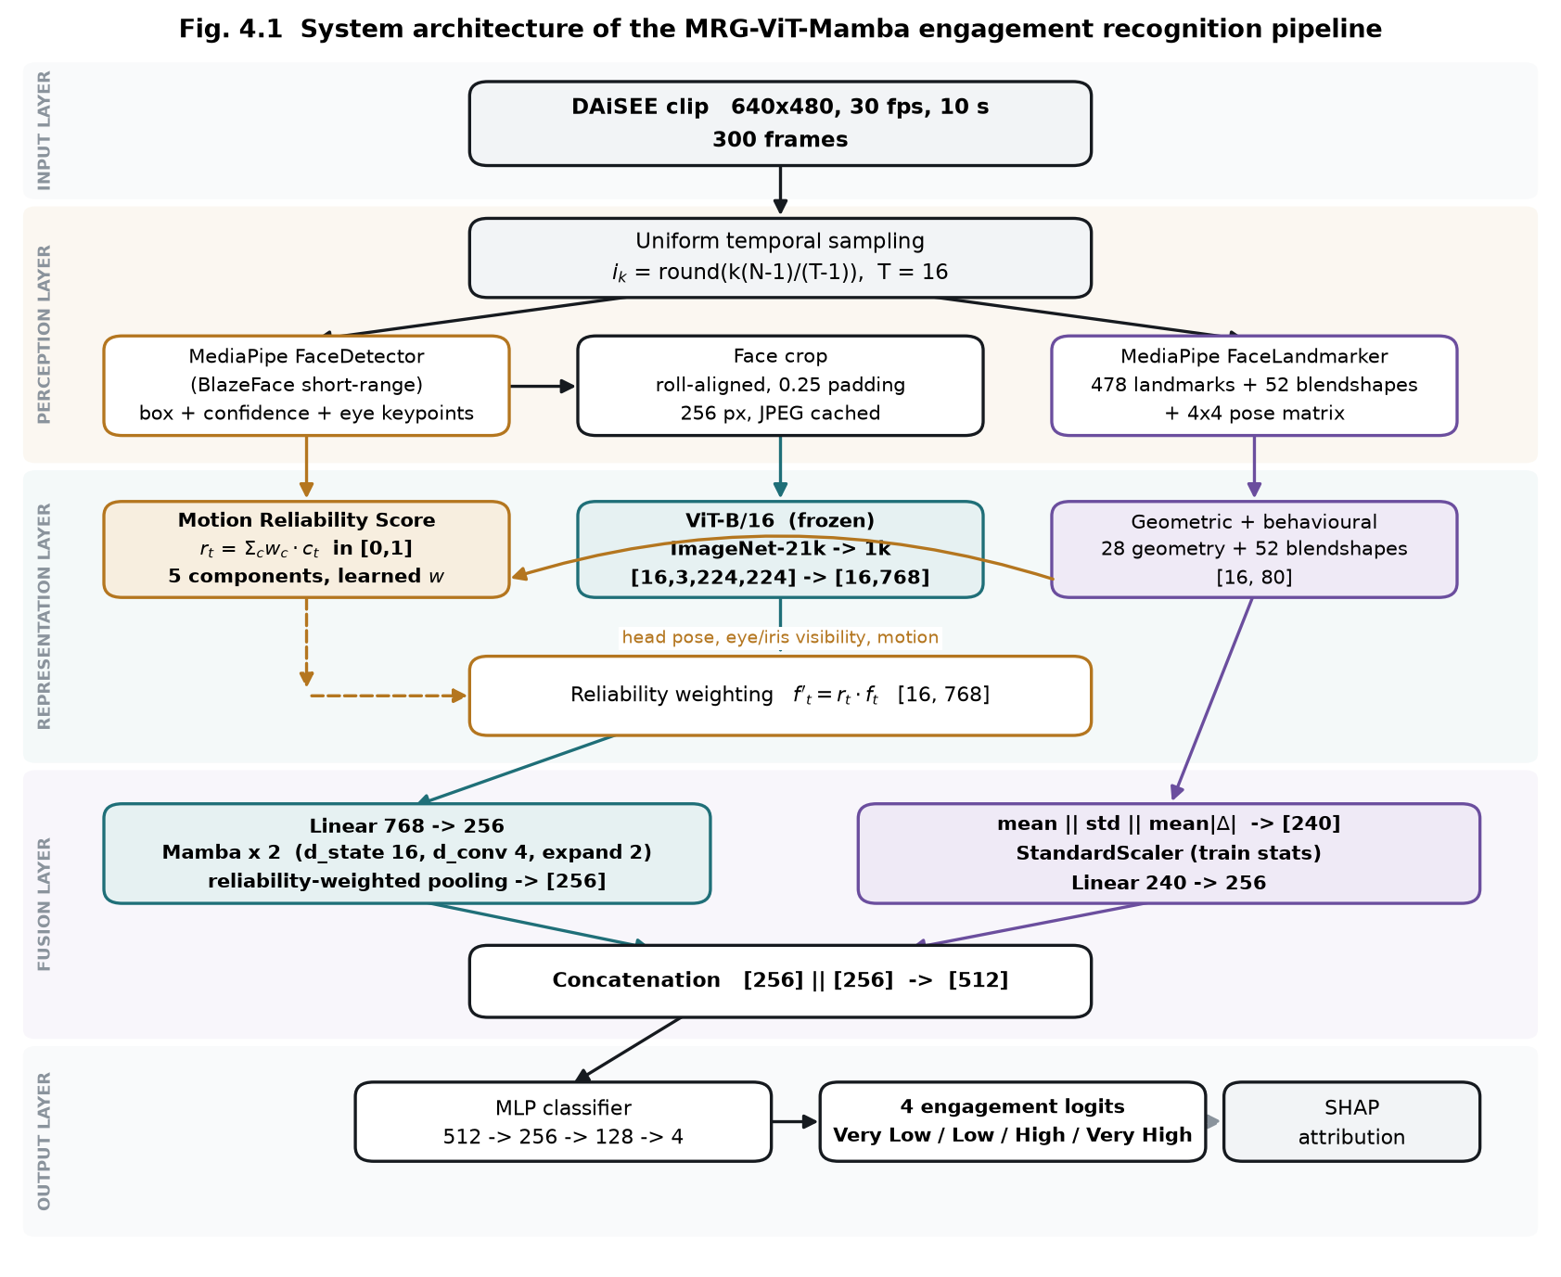
Fig. 1. Pipeline. Reliability is applied as a weight at two points and never removes a temporal position.
Reliability enters at two points. Each embedding is scaled by its own reliability, and the temporal pooling that follows the state-space encoder is a reliability-weighted average rather than a mean. Neither operation removes a frame: the number and ordering of temporal positions is preserved, so the encoder still receives a regularly sampled sequence. The temporal encoder is a two-layer Mamba [8] model at 256 dimensions.
A parallel branch aggregates the per-frame landmark geometry into a 240-dimensional clip descriptor by taking the mean, standard deviation and mean absolute temporal difference of each named feature. Its standardiser is fitted on the training partition alone. The two branches are projected to 256 dimensions and concatenated, and a multilayer perceptron produces the class logits. The assembled model has 87.2 million parameters, of which 28.4 million of the backbone's 85.8 million are trainable; the parts specific to this work total 1.27 million.

Training and Evaluation
Class imbalance is addressed at two independent points: how often each class is drawn, through a weighted sampler, and how much each error costs, through class-weighted loss. The two are not combined, because their effects multiply. On the binary task the sampler alone raises the minority class from 4.6% to 27.8% of draws; adding effective-number weights [16] on top would place the effective prior near 81% when the true rate is 4.6%.
The checkpoint is selected on validation balanced accuracy. Selecting on raw accuracy is unsound on this distribution: in a preliminary run the highest validation accuracy, 0.579, occurred at epoch 0 against a validation majority baseline of 0.569, that is, on a model that had barely departed from the prior. The test partition is read once per run, after selection, and never informs it.
[TO COMPLETE] Hardware used for the reported runs: insert the GPU model, memory and total training time if the reviewers ask for reproducibility details.

Results

Three-Class Engagement Recognition
Table II reports the three-class results. The system exceeds the majority baseline on balanced accuracy and macro F1 and falls below it on raw accuracy. Both statements hold and they measure different quantities: a constant majority predictor attains 0.4944 accuracy while scoring 0.3333 balanced accuracy and 0.2206 macro F1.
TABLE II. Three-Class Results on the Full DAiSEE Test Partition (1,784 Clips)
Metric | Model | Majority baseline
Accuracy | 0.4596 | 0.4944
Balanced accuracy | 0.4185 | 0.3333
Macro F1 | 0.3833 | 0.2206
Weighted F1 | 0.4661 | —

The confusion structure locates the limitation. Of 1,696 clips labelled High or Very High, 308 true High clips are predicted Very High and 414 true Very High clips are predicted High. Restricting the model to a forced two-way choice between those two classes yields 0.5153 accuracy against 0.5200 for always answering High, and a ROC-AUC of 0.5235 where 0.5 denotes no signal.
Because those classes constitute 95% of the test partition, this bounds overall accuracy. Re-deciding the stored test probabilities confirms it: correcting for the class-weighted loss raises accuracy to 0.4849, and suppressing the rare class entirely raises it to 0.4899, both below the 0.4944 baseline. No loss, sampler or threshold lifts accuracy above the prior while the High to Very High boundary carries no learnable signal.

Binary Disengagement Detection
Reformulated as detection of disengagement, the same architecture yields a usable result. Accuracy is reported but is not the headline: the test partition contains 1,696 engaged and 88 not-engaged clips, so a constant engaged prediction scores 0.9507 while detecting nothing, and a detector that predicts the minority class sometimes necessarily scores lower. ROC-AUC is threshold-free and unaffected by the class ratio.
TABLE III. Binary Disengagement Detection on the Full Test Partition
Metric | Model | Baseline
ROC-AUC | 0.7943 | 0.5000
Average precision | 0.2628 | 0.0493
Balanced accuracy | 0.7316 | 0.5000
Accuracy | 0.8380 | 0.9507
Recall (not engaged) | 0.614 | 0.000
Precision (not engaged) | 0.175 | —
54 of 88 disengaged clips recovered, with 255 false alarms.
Fig. 2 shows the confusion matrix. Training on the full release rather than a 1,500-clip subset raised ROC-AUC from 0.7324 to 0.7943, consistent with the minority count being the binding constraint: the subset contained 69 not-engaged training clips against 247 in the full partition.
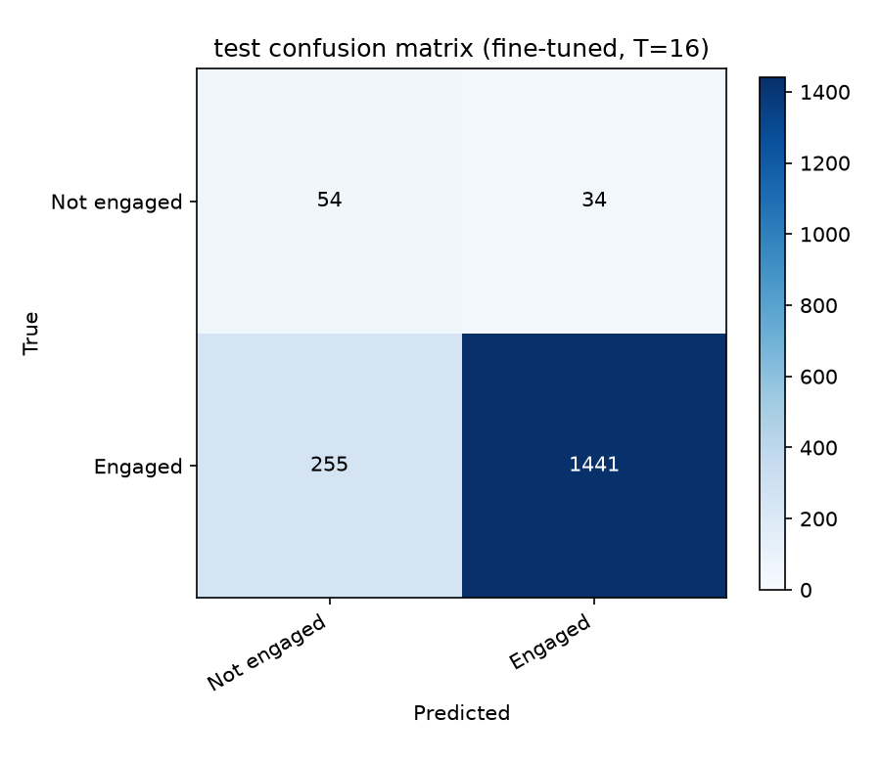
Fig. 2. Confusion matrix for binary disengagement detection on the full test partition.

Ablation of the Reliability Mechanism
The central hypothesis requires a control: the same model with the mechanism removed, trained on the same clips with the same seed. Two configurations were compared that differ in exactly two of 117 settings, namely whether reliability scales the frame embeddings and whether temporal pooling is reliability-weighted or a plain mean.
TABLE IV. Controlled Ablation on the Full Test Partition
Configuration | ROC-AUC | AP | Balanced acc.
Reliability weighting on | 0.7943 | 0.2628 | 0.7316
Reliability weighting removed | 0.7941 | 0.2627 | 0.7313
Difference | +0.0002 | +0.0001 | +0.0003

The difference is 0.0002 ROC-AUC, and on the validation partition the control was marginally ahead. Reliability weighting as implemented here does not measurably improve recognition on this dataset.
An earlier ablation over seven architectural variants with five seeds each, conducted on a 120-clip development subset, could not resolve this question. The full model scored 0.214 plus or minus 0.024 test macro F1 against 0.205 plus or minus 0.029 for the variant with reliability removed: a difference of 0.0090 against a pooled standard deviation of 0.0266. The smallest difference five seeds could declare significant at the 5% level was 0.0388, more than four times the observed effect, and establishing a 0.0090 effect at 80% power would have required approximately 137 seeds per arm. The full-scale comparison resolves what the development-scale one could not.

Collapse of Learned Mixture Weights
A silent failure mode emerged during full-scale training. Trained without regularisation, the five weights collapse: a fifteen-epoch run ended with motion consistency at 0.990 and the remaining four components near 0.001. A five-component reliability score had become a one-component score, with no error raised.
Simulation over the same number of optimiser steps shows that the learning rate does not control this, whereas weight decay does, because a parameter vector of zero is exactly the uniform weighting and decay is therefore a prior toward it. Table V reports the simulated maxima.
TABLE V. Simulated Maximum Component Weight after a Full Run
Learning rate | Weight decay | Maximum weight
0.04 | 0.0 | 1.000 (observed failure)
0.002 | 0.0 | 0.999 (lower rate does not help)
0.002 | 0.5 | 0.902
0.01 | 1.0 | 0.649 (bounded)

The prior does not merely freeze the weights. Under a weak noisy signal a component still separates to approximately 0.30 against 0.17 for the others, and under pure noise all five remain at 0.20. With the prior in place, three subsequent runs ended with all five components between 0.182 and 0.218.

Explainability
SHAP attribution over the fused representation was computed for 512 test clips against 512 background clips. Group totals are sums over groups of differing size, so the per-dimension column is the comparable one.
TABLE VI. SHAP Attribution by Feature Group, 512 Test Clips
Group | Dim. | Share | Per dim.
Deep temporal (ViT–Mamba) | 256 | 42.77% | 0.00257
Iris and gaze | 45 | 15.28% | 0.00523
Mouth and jaw | 90 | 15.10% | 0.00258
Eye openness | 36 | 12.56% | 0.00537
Brow | 27 | 6.62% | 0.00378
Head pose | 15 | 2.89% | 0.00297
Face scale | 9 | 2.74% | 0.00469
Cheek and nose | 15 | 1.83% | 0.00188

Per dimension, eye openness and iris or gaze features carry approximately twice the attribution of the deep temporal block; the latter's larger total share is substantially a consequence of its 256 dimensions against 240 for all landmark groups combined. The five highest-ranked individual features are all eye-related, as Fig. 3 shows: brow lowering, eye aspect ratio and eye openness for both eyes, followed by gaze direction and blink.
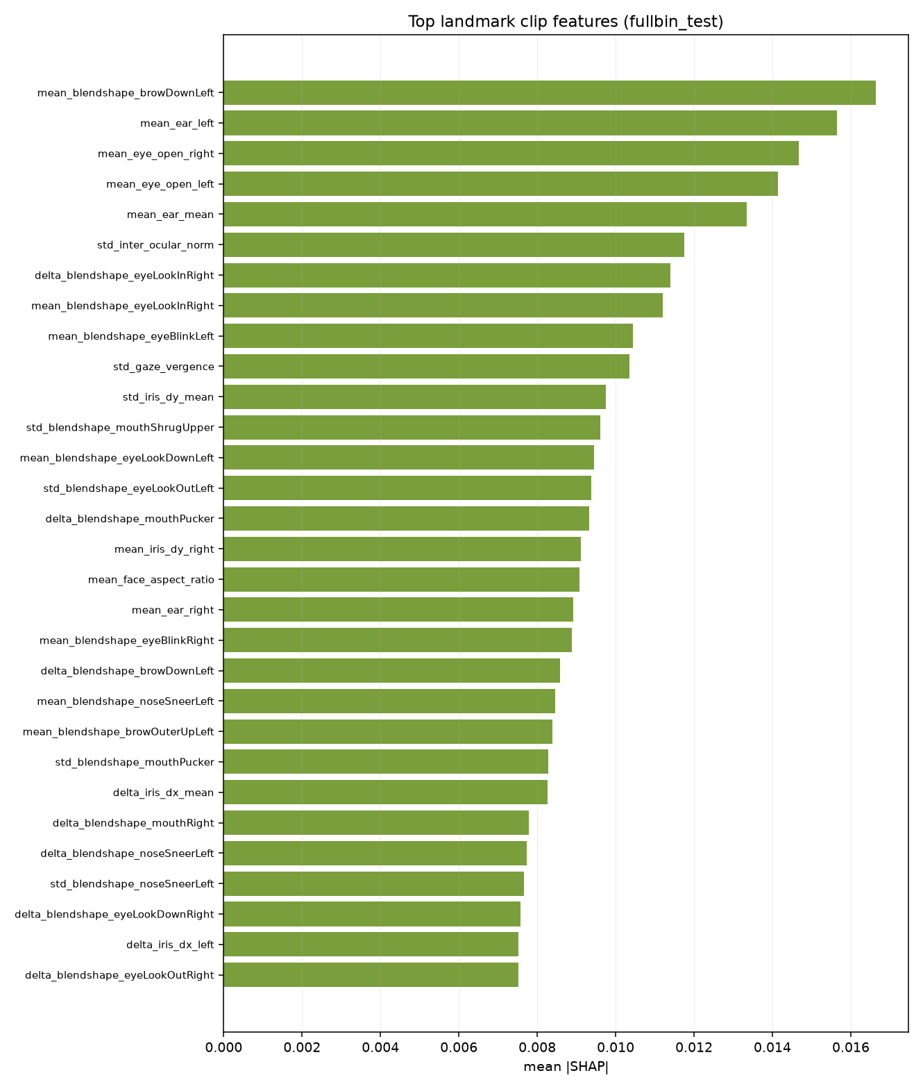
Fig. 3. Named landmark features ranked by mean absolute SHAP value.
Integrated gradients on individual clips corroborate this with a qualification. On three worked examples the landmark branch contributed +2.14, +1.51 and +1.56 to the predicted-class score while the deep branch contributed −0.35, −0.14 and +0.12. Read together with the SHAP result, the consistent interpretation is that the deep block carries comparable attribution magnitude but does not push consistently toward the correct class, whereas the landmark geometry does.

Discussion
Three findings follow, and they are not all favourable to the hypothesis this work set out to test.
The architecture yields a usable disengagement detector. A ROC-AUC of 0.7943 against a 0.5 no-signal baseline, with average precision 5.3 times its own baseline, is a real capability on a corpus where 95% of clips belong to one class.
The reliability mechanism does not account for it. The controlled ablation places its contribution at 0.0002 ROC-AUC, and attribution analysis assigns the discriminative signal to MediaPipe eye and gaze geometry rather than to the reliability-weighted deep representation.
The fine-grained formulation is bounded by annotation ambiguity rather than by model capacity. With a ROC-AUC of 0.5235 separating High from Very High, and those classes comprising 95% of the test partition, no decision rule can raise accuracy above the 0.4944 prior.
One limitation of the ablation must be stated. Both arms selected their best checkpoint at the first epoch, and across the epochs trained the learned weights moved only between 0.182 and 0.218 from their uniform initialisation. The comparison therefore contrasts reliability weighting with a near-uniform mixture against no weighting at all; the learned component of the contribution remains untested rather than refuted, because the model overfits before the weights have travelled far. A regime in which the backbone is frozen, and training is cheap enough to run hundreds of epochs across several seeds, would test it properly.
Two further limitations bear on interpretation. All full-scale comparisons report a single seed per configuration, and the development-scale ablation showed a seed-to-seed standard deviation of 0.0266 in macro F1, so differences below roughly 0.04 cannot be distinguished without repetition. No external published system was re-run on this protocol; published DAiSEE figures differ in partition, evaluation granularity and class formulation, and are not directly comparable.

Conclusion
This work evaluated whether treating observation reliability as a length-preserving, learned weight improves engagement recognition from webcam video. It delivered a verified pipeline on the full DAiSEE release and answered the question, though not in the direction anticipated: the mechanism's measured contribution is 0.0002 ROC-AUC under a controlled ablation differing in two of 117 settings.
The useful outcomes are elsewhere. As a disengagement detector the system reaches ROC-AUC 0.7943 against a 0.5 baseline, recovering 54 of 88 disengaged test clips. Attribution analysis localises the signal to eye openness and gaze geometry, which suggests that a far smaller landmark-only model may suffice and is a direct target for future work. The collapse of softmax-parameterised mixture weights, and the finding that weight decay rather than learning rate bounds it, generalises to any system that learns a convex combination of components in this way.
Future work should give the learned weights a fair test under a frozen backbone, exploit the three unused affect annotations through multi-task training, and model the intensity levels as ordinal rather than categorical, which targets the adjacent-class boundary where the present model is at chance.

CRediT Authorship Contribution Statement
[TO COMPLETE] Declare each author's contribution using the CRediT roles: conceptualization, software, data curation, formal analysis, investigation, methodology, project administration, resources, supervision, validation, visualization, writing - original draft, writing - review and editing.

Data Statement
This study uses the publicly available DAiSEE corpus, released for research under a registration agreement and obtainable from its authors. No new data were collected. The dataset video, the derived face crops and the extracted biometric landmark data are not redistributed with this work, in keeping with the licence conditions.
[TO COMPLETE] If your source code will be released, state the repository URL and licence here.

Declaration of Conflicts of Interest
[TO COMPLETE] State any competing interests, or write that the authors declare no conflict of interest.

Acknowledgment
The authors thank the School of Computer Science and Engineering, Vellore Institute of Technology, for providing the computing resources used in this work, and the creators of DAiSEE for making the dataset available for research.
[TO COMPLETE] Funding: the template requires funding sources to be disclosed. State the grant number and funder, or that the work received no external funding.

References
- A. Gupta, A. D'Cunha, K. Awasthi, V. Balasubramanian, “DAiSEE: towards user engagement recognition in the wild,” arXiv:1609.01885, 2016. [Online]. Available: https://arxiv.org/abs/1609.01885
- ViBED-Net Authors, “ViBED-Net: video based engagement detection network using face-aware and scene-aware spatiotemporal cues,” arXiv:2510.18016, 2025. [Online]. Available: https://arxiv.org/abs/2510.18016
- J. Whitehill, Z. Serpell, Y.-C. Lin, A. Foster, J. R. Movellan, “The faces of engagement: automatic recognition of student engagement from facial expressions,” IEEE Transactions on Affective Computing, vol. 5, no. 1, pp. 86-98, 2014.
- J. Donahue, L. A. Hendricks, S. Guadarrama, M. Rohrbach, S. Venugopalan, K. Saenko, T. Darrell, “Long-term recurrent convolutional networks for visual recognition and description,” in Proceedings of the IEEE Conference on Computer Vision and Pattern Recognition, Boston, MA, USA, 2015, pp. 2625-2634.
- D. Tran, L. Bourdev, R. Fergus, L. Torresani, M. Paluri, “Learning spatiotemporal features with 3D convolutional networks,” in Proceedings of the IEEE International Conference on Computer Vision, Santiago, Chile, 2015, pp. 4489-4497.
- G. Bertasius, H. Wang, L. Torresani, “Is space-time attention all you need for video understanding?,” in Proceedings of the International Conference on Machine Learning, 2021, pp. 813-824.
- Ö. Sümer, P. Goldberg, S. D'Mello, P. Gerjets, U. Trautwein, E. Kasneci, “Multimodal engagement analysis from facial videos in the classroom,” IEEE Transactions on Affective Computing, vol. 14, no. 2, pp. 1012-1027, 2023.
- A. Gu, T. Dao, “Mamba: linear-time sequence modeling with selective state spaces,” arXiv:2312.00752, 2023. [Online]. Available: https://arxiv.org/abs/2312.00752
- L. Zhu, B. Liao, Q. Zhang, X. Wang, W. Liu, X. Wang, “Vision Mamba: efficient visual representation learning with bidirectional state space model,” in Proceedings of the International Conference on Machine Learning, 2024.
- A. Dosovitskiy, L. Beyer, A. Kolesnikov, D. Weissenborn, X. Zhai, T. Unterthiner, M. Dehghani, M. Minderer, G. Heigold, S. Gelly, J. Uszkoreit, N. Houlsby, “An image is worth 16x16 words: transformers for image recognition at scale,” in Proceedings of the International Conference on Learning Representations, 2021.
- C. Lugaresi, J. Tang, H. Nash, C. McClanahan, E. Uboweja, M. Hays, F. Zhang, C.-L. Chang, M. G. Yong, J. Lee, W.-T. Chang, W. Hua, M. Georg, M. Grundmann, “MediaPipe: a framework for building perception pipelines,” arXiv:1906.08172, 2019. [Online]. Available: https://arxiv.org/abs/1906.08172
- J. L. Pech-Pacheco, G. Cristóbal, J. Chamorro-Martínez, J. Fernández-Valdivia, “Diatom autofocusing in brightfield microscopy: a comparative study,” in Proceedings of the International Conference on Pattern Recognition, Barcelona, Spain, 2000, pp. 314-317.
- P. Terhörst, J. N. Kolf, N. Damer, F. Kirchbuchner, A. Kuijper, “SER-FIQ: unsupervised estimation of face image quality based on stochastic embedding robustness,” in Proceedings of the IEEE Conference on Computer Vision and Pattern Recognition, Seattle, WA, USA, 2020, pp. 5651-5660.
- J. Yang, P. Ren, D. Zhang, D. Chen, F. Wen, H. Li, G. Hua, “Neural aggregation network for video face recognition,” in Proceedings of the IEEE Conference on Computer Vision and Pattern Recognition, Honolulu, HI, USA, 2017, pp. 4362-4371.
- S. M. Lundberg, S.-I. Lee, “A unified approach to interpreting model predictions,” in Advances in Neural Information Processing Systems, Long Beach, CA, USA, 2017, pp. 4765-4774.
- Y. Cui, M. Jia, T.-Y. Lin, Y. Song, S. Belongie, “Class-balanced loss based on effective number of samples,” in Proceedings of the IEEE Conference on Computer Vision and Pattern Recognition, Long Beach, CA, USA, 2019, pp. 9268-9277.

It is recommended that footnotes be avoided (except for the unnumbered footnote with the receipt date on the first page). Instead, try to integrate the footnote information into the text.

